19.1.6 Editors - NLA Editor - Add Menu
NLA Editor - Add Menu 1
Add Action Strip 1
Add Transition 1
Add Sound Clip 1
Add Meta Strips 1
Remove Meta Strips 2
Add Tracks 2
Add Tracks Above Selected 2
Include Selected Objects 2

NLA Editor - Add Menu
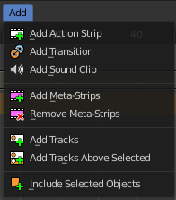
A menu where you can add various elements to the NLA.

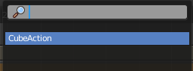
Add Action Strip
Adds an action strip. Opens a popup menu where you can choose what animation data this new action strip should contain.

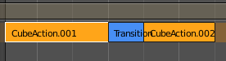
Add Transition
Adds a transition strip between two selected action strips.

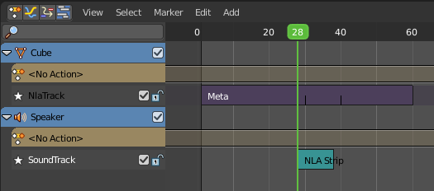
Add Sound Clip
Adds a sound clip at the marker position.
A Sound Clip Controls when a speaker plays a sound. This strip type requires a Speaker object with a sound clip assigned. You can create a speaker object in the 3D view. The sample can be loaded in the Object Data Properties tab in the Properties editor then.

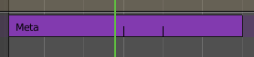
Add Meta Strips
Turns selected strips into a meta strip. A group of strips.

Remove Meta Strips
Ungroups the meta strips into its original action strips.

Add Tracks
Adds a new track in the Channel list.

Add Tracks Above Selected
Adds a new track in the Channel list.

Include Selected Objects
Objects without animation or a NLA strip will not appear in the channel list. With this command you can load selected objects into the NLA, regardless if they have animation yet or not.

